Ceramics 2 Syllabus Ms. Heida 763-506-8546

[angela.heida@ahschools.us](mailto:angela.heida@ahschools.us)

**Common Art Department Syllabus:**

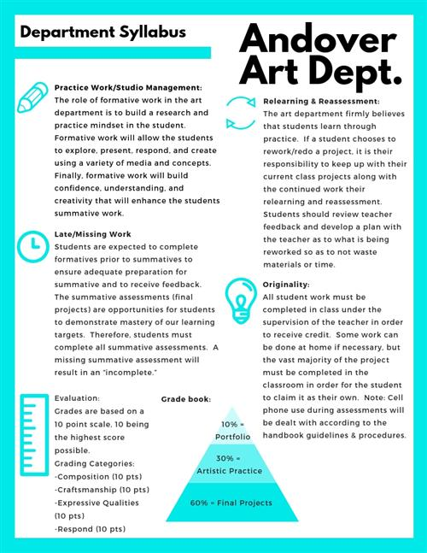

**Projects:**

**Thrown Work Unit:**

Students will demonstrate on the wheel:

1. Mug 2) Plate 3) Seated lid with vessel 4) Chip/Dip Bowl

**Hamada Bottle**: Use a combination of hand-building and throwing techniques to make a bottle in the style of Shoji Hamada.

**Outside Influence Piece:**  **Teapot and Cup**

Students will learn how to make a functional teapot. Handles, spout, foot, and lids will be included. The cup and teapot should be a “set”; related in form and features.

**Saggar Fired Vessel:** Students will create a piece for an alternative firing, prepare it accordingly and assist in the firing process of their work.

**Animal Inspired Piece:**

Students will create an animal inspired piece in the method of their choosing.

**Negative Space Inspired**

Students will make an original artwork and carefully remove at least 50% of it to create thoughtful spaces.

**_________________________________________________________________**

**Artists covered:** Shoji Hamada, Helga Gamboa, Isaac Buttons, Warren McKenzie and others.

**Grading:**

**60% Summative Projects, 20% Formative Projects, 20% Studio Performance**

The summative projects receive three grades on a 10 point scale for Craftsmanship, Expressive Qualities and Form. Formative projects receive one grade showing progress toward the learning target. Studio performance is based on a student’s contribution to the art studio and use of work time. You will receive full points if you are on task in class, on time for class, follow school policies on food and phones. If you are ever unsatisfied with a grade please see me and we can discuss how to improve it within grading deadlines. Late work will be accepted if turned in before the next projects grading deadline. I do not give extra credit however; you have the option to redo any project for a higher grade within grading deadlines. **All projects must be completed to receive credit for this class.**

School and district policies on cell phone appearance during tests/quizzes result in a zero; and that modifications may be made regarding grading and IEP and 504 plans will be followed.

If your parent(s) and/or guardians have a special art related talent or work that they would be willing to share with the class, please let me know. It would be an enriching experience for the class.